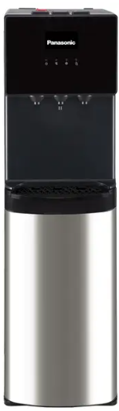

Panasonic Dispenser
Rs.52,000
A Panasonic water dispenser is a convenient appliance that provides instant hot, cold, and normal water, making it ideal for homes, offices, and daily use with modern safety and hygiene features.

Specifications
- Power: ~520W
- Voltage: 220–240V, 50/60Hz
- Dimensions: Approx. 1040 × 310 × 360 mm
- Noise Level: ≤50 dB

Key Features
- 3-in-1 Water Options
- Advanced Filtration System
- Bottom or Top Loading Design
- Child Safety Lock

